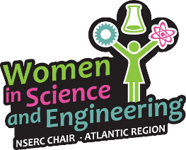
WISEatlantic Partnerships Program Abstract
Organization or Individual’s name: ____________________________________________________
Project Title: ___________________________________________________________
Project Dates: ___________________________________________________________
Funding Requested: ___________________________________________________________

Organization/Individual’s Contact Information:
Mailing Address: ___________________________________________________________
___________________________________________________________
Phone Number: _____________________________________________
Website (if applicable): _____________________________________________
Affiliation:
- Post-Secondary Institution (name):
- Charitable / Non-Profit Organization (name and registration number):

Primary contact:
Name: _______________________________________________________________________
Position in Organization: _________________________________________________________
Email: ________________________________________________________________________

Phase 1: One-page Abstract & Project Budget – Due October 10, 2017
Attach a one-page abstract that summarizes your organization and the project.
Attach a project budget showing anticipated funding sources and expenses. Please note that all expenses must comply with NSERC’s list of eligible grant expenses, as well as Mount Saint Vincent University’s policy for travel (e.g. per diem travel rates). For a complete list of NSERC eligible expenses click here. For details on the Mount’s policy please contact us at WISEatlantic@msvu.ca

